#
# 20171103
# It was task SD#794432 made by Begizardov Pavel. He used differ temlate for one virtual machine. And I have difficulties, respectively.

[s.belogrud@TCS4357]# ssh root@hq-msk-vol-tcb-prod-red-1
Connection closed by 172.16.1.6
[s.belogrud@TCS4357]#

# To be sure - I’ve tested follow option.
root@hq-msk-vol-tcb-prod-red-1:~# grep "^PermitRootLogin" /etc/ssh/sshd_config
PermitRootLogin yes
root@hq-msk-vol-tcb-prod-red-1:~#

# There were follow messages find by me in log file.

root@hq-msk-vol-tcb-prod-red-1:~# less /var/log/auth.log
...
Nov 3 16:59:47 hq-msk-vol-tcb-prod-red-1 sshd[6534]: error: Could not load host key: /etc/ssh/ssh_host_dsa_key
Nov 3 16:59:47 hq-msk-vol-tcb-prod-red-1 sshd[6534]: error: Could not load host key: /etc/ssh/ssh_host_ecdsa_key
Nov 3 16:59:47 hq-msk-vol-tcb-prod-red-1 sshd[6534]: error: Could not load host key: /etc/ssh/ssh_host_ed25519_key
...

# I’ve created appropriate key file and test it.
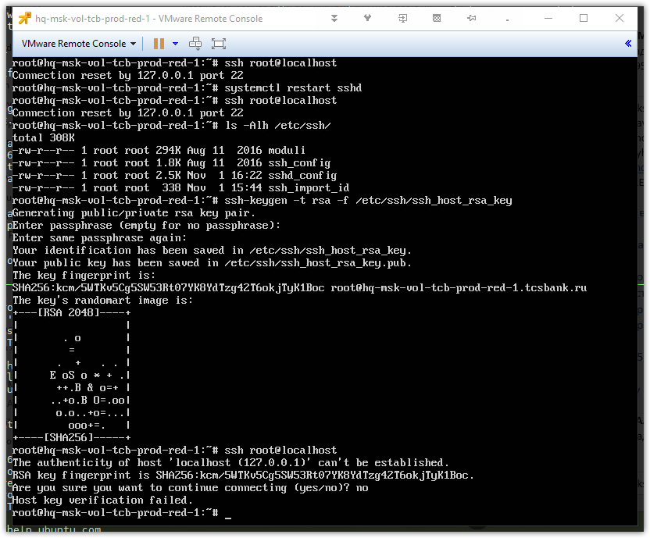

# After that this virtual machine starts working to allow connect it via ssh.

